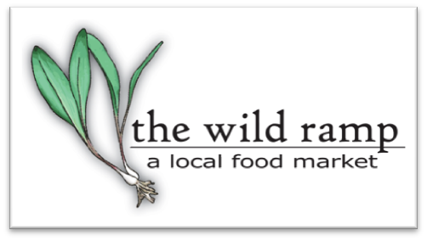
FOR INTERNAL USE ONLY
Producer # _____________
Retail Edge________
Master List________
Copy to Acct __________
Original Filed ___________
ACH or paper__________
W9 ______________

PRODUCER APPLICATION
Please direct all questions to wrmarketdirector@gmail.com or 304-523-7267

Name(s) _______________________________

Farm/Business Name

Mailing Address (NO P.O. BOXES)
Physical Address of Farm (if different than above)_____________________________________

City State_________ Zip Code County _
Phone Email _____________________

Facebook_____________________________ Instagram____________________________
Web page________________________________________________

Photos: Please also attach some photos to your application of your staff, products, farm, etc. which will be used for social media promotion of your business and the market overall.

Circle or highlight which apply : Are you applying as a….

Producer (you grow raw food such as vegetables or fruits)

Value-Added (you make baked goods, dried goods, canned goods from raw food)

Arts Vendor( you create non-edible goods)

Please list in detail ALL the items you intend to sell. If you are selling produce please list varieties and locations if it is grown differently from the location listed above. (EX: tomatoes, Mr. Stripey)

__________________________________________________________________________________

________________________________________________________________________________

________________________________________________________________________________

________________________________________________________________________________

Please describe in your own words how your farming methods produce a high quality product and show care and respect for the environment, your business, community, and the soil. If applicable, please discuss pest and weed control practices and animal nutrition, health, and physical surroundings.

If you are a crafter or artisan maker please describe the process of how you make your items and what/if any local products or materials are used in your process.

__________________________________________________________________________________

________________________________________________________________________________

________________________________________________________________________________

_______________________________________________________________________________

________________________________________________________________________________

Please describe the size of your operation (# of acres in production, # of employees, etc..)

________________________________________________________________________________

________________________________________________________________________________

________________________________________________________________________________

How long have you been in operation? _______________________________________________________

Are you GAP certified? __________ YES __________ NO
Are any of your products Certified Organic? __________YES __________NO

Do you hold any other sustainability-related certificates? _______YES ______NO
If Yes, please attach copies with your application for submission and review.

Do you seasonally pasture your animals? _______YES _______NO
Do you routinely use antibiotics on your livestock? _______YES _______NO

Do you use any chemical sprays and/or synthetics or fertilizers? ____YES ____NO
If yes, please list and for what purpose:

________________________________________________________________________________

________________________________________________________________________________

Do you use NON-GMO seeds? __________YES __________NO
Do you use NON-GMO feed? __________YES __________NO

Do you use a co-packer to make your products? _______YES _______NO
If yes, please explain what involvement you have in the development and production of your products:

________________________________________________________________________________

________________________________________________________________________________

Agreement
I have read and understand The Wild Ramp Market Rules, Procedures & Guidelines. I agree to comply with The Wild Ramp market rules, regulations and requirements. I have signed and attached a W-9 form for tax purposes. I affirm that all information in this application is complete and accurate.

Signed

Date

Attach copies of all licenses that apply

Financial Information

Checks should be made payable to: ___________________________________________________

Tax ID# or SS# ___________________________________________________________________

*** If you would like payments to be electronically deposited in your account please complete the DIRECT DEPOSIT AUTHORIZATION FORM and submit a voided check with this signed application. ***

